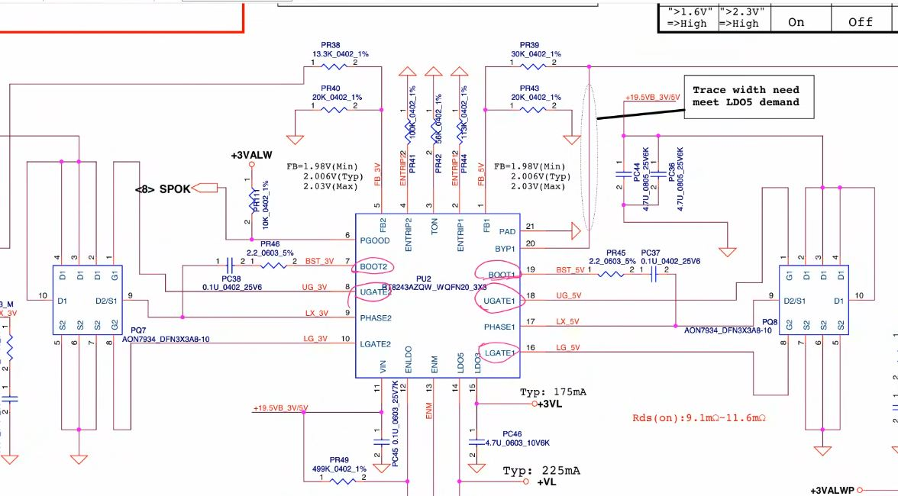Dual 3V and 5V (Regulator)
Process- there are two enable concept one for LDO and another for Regulator.
Part 1: Generate LDO (Linear voltage)
- VCC 19 v
- ENLDO(enable LDO) By voltage devider/ic
- LDO3/VREG3( send to SIO), LDO5/VREG5 (3VL OUTPUT)/ (5VL OUTPUT)
LDO3 send to SIO(V standby pin)
When the Power Button is pressed, SIO generates the EN Signal and send to the back IC 3/5 because this buck converter requires an enable signal to turn on
Part 2: Generate 3/5volt (Buck converter)
- ENM (enable master from SIO/PCH/RTC/IC Circuit) 3volt (to activate buck converter)
- ENTRIP1, ENTRIP2(voltage hai to regulator on hai)
ENTRIP (Enable or Trip) Jab resister ke according (128k/100=1.2 v) hai to enable hai OR 0v hai to trip hai fir 3/5 volt coil section check krna hai.
- BOOT1, BOOT2
- UGATE1, UGATE2
- LGATE1(should be low hight(3,4, 5 hoga to switching start nhi hoga)), LGATE2
- PHASE1(mosfet output voltage feedback), BOOT1, UGATE, LGATE – internal process
- FB1
- PGOOD(output pin sending info this department/section is working fine) 3volt
Kabhi bhi Lower mosfet on nhi hona chaihiye, hai to 0v ho jayega, switching start nhi hogi
Note
Before the Power Button is pressed, a 3-volt Leaner supply and after the power button is pressed, a 3/5volt buck convertor supply
Every Buck converter has Enable and Power_Good
3/5V Regulator IC - LDO and Switching voltage out krta hai…
Difference LDO – Low ampier (used for sending info) and Switching Voltage(VALW) – high ampier (user for working)
LDO (Low Dropout)
StepDown IC se out hota jo kafi jagah jata hai.
Main kaam SIO and PCH ko jagana intialize krna hota hai

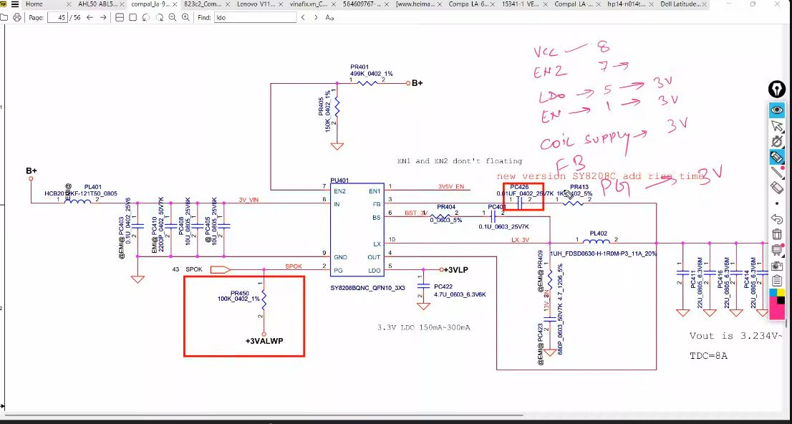
Single IC 3V (Regulator)

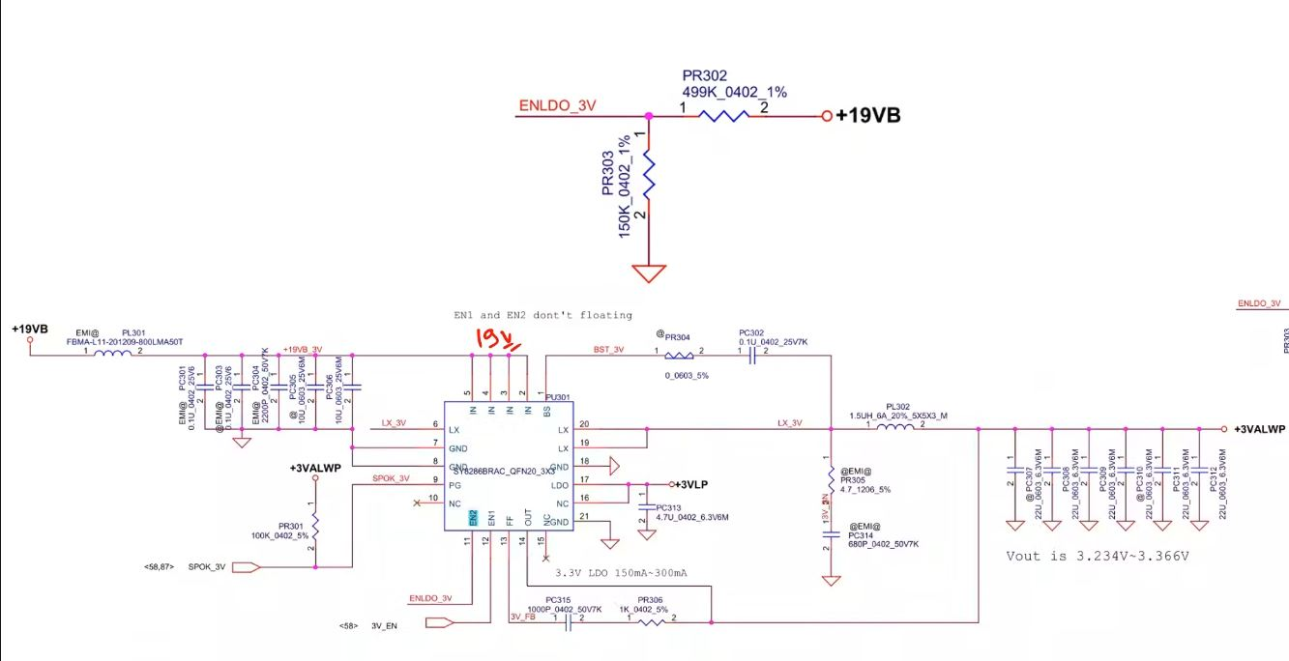

Shortcut to find by enldo
Process – there are 2 enable concept one for LDO and another for Regulator
Part 1 LDO Generate
- In(VCC)
- EN2 (=ENLDO)– by voltage devider/ ise self bhi generate kr sakati hai
- LDO- 3VLP (Direct without enable)
("+3VLP" refers to a +3.3V Low Drop-Out (LDO) It is a critical, always-on voltage used to power the Embedded Controller (EC) and initialise the system before main power rails activate)
Part 2 Generate 3/5 volt
- EN1 ~3volt – (from SIO)
First SIO Requirement puri karni hai
3VLP distribution search krenge
(issi se on/off hota hai)
Note:
3 volt regulator suppy se pehle LDO banta hai
https://www.youtube.com/watch?v=HUelstoHB3k
Laptop Stepdown Section || +3V and +5V ALW Supply Section || LDO Supply (All Pins are explained)
https://www.youtube.com/watch?v=mhKWHSK1htM

